Chapter test with answers
Chapter 2 Classifying and separating substances
Time permitted: 30 minutes
 | Section | Number of questions | Marks available
A | Multiple choice | 15 | 15
B | Short answer | 5 | 15
 | Total |  | 30
Scale:
A+ | 29–30 | A | 26–28 | B | 23–25 | C | 19–22 | D | 15–18 | E | 9–14 | UG | 0–8

Section A Multiple choice (15 marks)
Section A consists of 15 questions, each worth one mark. Each question has only one correct answer. Circle the correct answer. Attempt all questions. Marks will not be deducted for incorrect answers. You are advised to spend no more than 15 minutes on this section.
1 Which of the following describes why water droplets appear on a cold bathroom mirror when you are having a hot shower?
A Evaporating
B Boiling
C Melting
D Condensing
2 In which of the following separation techniques is the term residue used?
A Evaporation
B Decanting
C Sieving
D Filtration
3 Which of the following could be removed using magnetic separation?
A Iron nail
B Aluminium foil
C Small pieces of tin
D Zinc shavings

4 Which of the following is an indicator of a physical change?
A A gas is produced.
B A precipitate is formed.
C There is a change in state.
D There is a significant change in temperature.
5 Immiscible liquids are generally separated in the science laboratory using:
A a filter funnel.
B a separating funnel.
C a condenser.
D a Bunsen burner and evaporating basin.
6 What does the term filtrate refer to?
A Smaller solid particles that pass through a sieve
B Solid particles that are too large to pass through filter paper
C The liquid or solution that passes through the filter paper
D The liquid or solution that remains after evaporating
7 Evaporation is used as a separation technique when:
A only the solute is to be kept.
B only the solvent is to be kept.
C solid particles can be seen in the mixture.
D both the solute and the solvent are to be kept.
8 Which of the following substances is the odd one out?
A Diamond
B Salty water
C Granite
D Sugar
9 Which of the following is not a mixture?
A Tap water
B Carbon dioxide gas
C Coffee
D Air
10 When a liquid is cooled enough, it will turn into a solid. The temperature at which this occurs is known as the:
A boiling point.
B melting point.
C state.
D thermal conductivity.

11 Which of the following mixtures could not be separated by sedimentation and decanting?
A Oil and water
B Peas in a saucepan of water
C Sandy water
D Coffee grounds in hot water
12 Mixtures that contain solids with different particle sizes are not usually separated by:
A sieving.
B vaporisation.
C filtration.
D straining.
13 During distillation, the thermometer is used to:
A work out when the substance with the highest boiling point has changed into a gas.
B control the temperature of the liquid or solution being heated in the round-bottom flask.
C determine the temperature of the vapour entering the condenser.
D ensure the experiment remains safe at all times when carried out in the laboratory.
14 Which of the following is always a mixture?
A An element
B A compound
C A liquid
D A solution
15 Which of the following is false?
A Mixtures can be solids, liquids or gases.
B Mixtures can be homogeneous or heterogeneous.
C Mixtures contain at least two different types of particle physically combined.
D Mixtures always have variable composition.

Section B Short answer (15 marks)
Section B consists of five questions. Write your answers in the spaces provided. You are advised to spend 20 minutes on this section.
1 Complete the following table.
Answer:
Separation method | Property used in the separation (with both components to be retained)
Separating funnel | The components are liquids with different densities
Filtration | The components are substances with different particle sizes
Distillation | The components are substances with different boiling points
(3 marks)
2 A student was given a mixture of sodium chloride (common table salt), small cork pieces, dirt and iron filings. Draw a flow chart to show the procedure the student should follow, if all components are required to be kept. Be sure to show what is removed at each step. (3 marks)
Answer: (Some students may do this differently.)
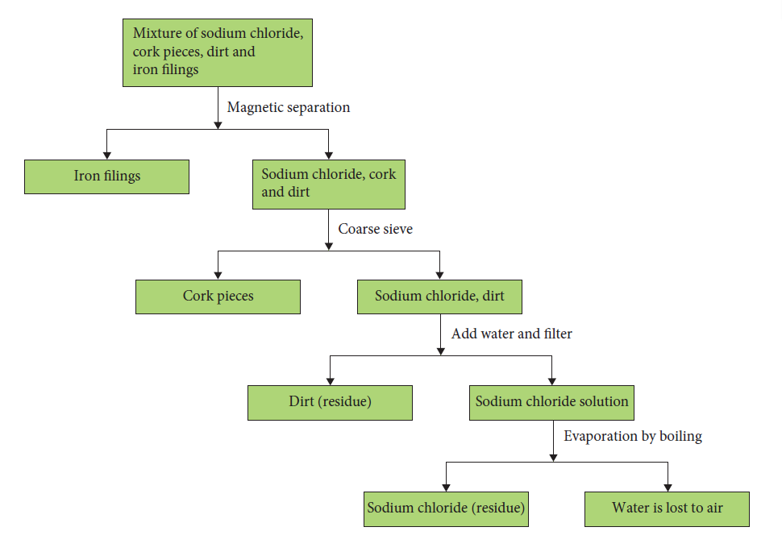

3 The table below compares some properties of two substances, I and II. Decide whether each substance is an element, compound or mixture. Give reasons for your answers. (3 marks)
Substance | Melting point | Separation/decomposition
I | No definite melting point | Components can be separated by physical means
II | > 900°C | Cannot be decomposed into simpler substances
Answer: Substance I is a mixture: mixtures are made up of different types of substances in differing amounts. (1 mark)
Hence the melting points are varied and the different components can be separated by physical means, such as filtration. (1 mark)
Substance II is an element, as it cannot be decomposed into a simpler substance. (1 mark)
4 Draw particle diagrams of specific examples of substances to illustrate the difference between a pure substance and a mixture. (3 marks)
Answer: Carbon dioxide gas is a pure substance. This is shown in the diagram below, as there is only one type of particle in the container. (1 mark)
Air is a mixture made up of a number of different gases, such as carbon dioxide, nitrogen gas and oxygen gas. This is shown below as there are four different types of particle in the container, physically combined. (1 mark)
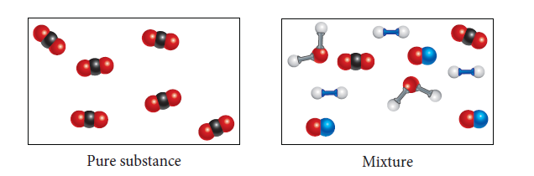 (1 mark)

5 Using correct scientific terminology, clearly explain how the process of distillation can be used to separate a mixture of water and ethanol (BP = 78°C). (3 marks)
Answer: The water and ethanol mixture is placed in the round-bottomed flask and heated to approximately 78°C using a water bath and hot plate. At this temperature, ethanol changes into a gas (evaporates) and rises from the surface. (1 mark)
The ethanol vapour enters the condenser tube, which has cool water running around the outside in the ‘water jacket’. This cools down the gas and condenses it back into a liquid, and it runs into a beaker as the distillate. (1 mark)
It is important not to let the temperature of the mixture reach 100°C or the water will also evaporate and be collected. The water stays in the round-bottomed flask. (1 mark)
End of test (30 marks)

